**Product Design**

**Project:** Amusement Park Website

**Team:**

Revision History

|  |  |  |
| --- | --- | --- |
| Date | Summary Of Changes | Author(s) |
| 19/09/2024 |  |  |

**Class Diagram**

**User**

This class saves the data of all users registered on the site, whether ordinary users or administrators. Depending on the role assigned to a user, the user can perform one or more activities. The attributes, which include their unique ID, name, email, password and role, definitely have to do with something. The User class also has methods for creating user accounts, logging in, viewing park information, booking rides, providing feedback, and social network sharing.

**Park**

Park class contains information about the amusement park and its services, rides, and mobility characteristics. This class deploys information about the park's name, position, working hours, and accessible trips and services. Park administrators can use this class to change or otherwise manage park information.

**Ride**

This class contains information on a ride in the amusement park, but only one ride. Its records include the name, description, unique characteristics, and current operation status. Users can observe details about a ride, schedule a ride, or enter a virtual queue if queuing is necessary.

**Service**

The Service class works with additional services that could be provided in the park, such as food-selling joints, washrooms or lodging facilities. All the services have attributes that include Service ID, Service Name, Service Description, and Operational Status. Users can either book a service, see the available services or check the status of any particular service.

**Booking**

The login class handles login requests, but more playfully, it has individual functionalities for login and logout or login to a certain level. It consists of fields like the booking ID, the user ID, the ride or the service to be booked, the booking date, and the booking status. Those are the methods through which users can view their bookings, update them or cancel them.

**Feedback**

The Feedback class facilitates comments and ratings on their experience at the park by the users. Every feedback entry is associated with a user and comprises the user's comments, rating, and the date the feedback was submitted. The admins can see feedback given by the user to check satisfaction levels.

**Admin**

The Admin class takes care of the park and its operations. Users are ordinary visitors of the park who mainly provide their feedback or rate the park; admins are persons with higher privileges who can modify park information, work with users' feedback, and generate reports. Another option is for the admins to log in with secure codes to the computer's boot.

**Notification**

The Notification class deals with sending real-time notifications to the users for the availability of the ride, ride booking, or closure of a ride. Users can select and enable these notification options; hence, they will receive the selected notification.

**VirtualQueue**

This class corresponds to the system of queues for virtual waiting for an attraction or a show where users can enter the queue and see the current queue number. You get notified when it is your turn to hold the microphone.

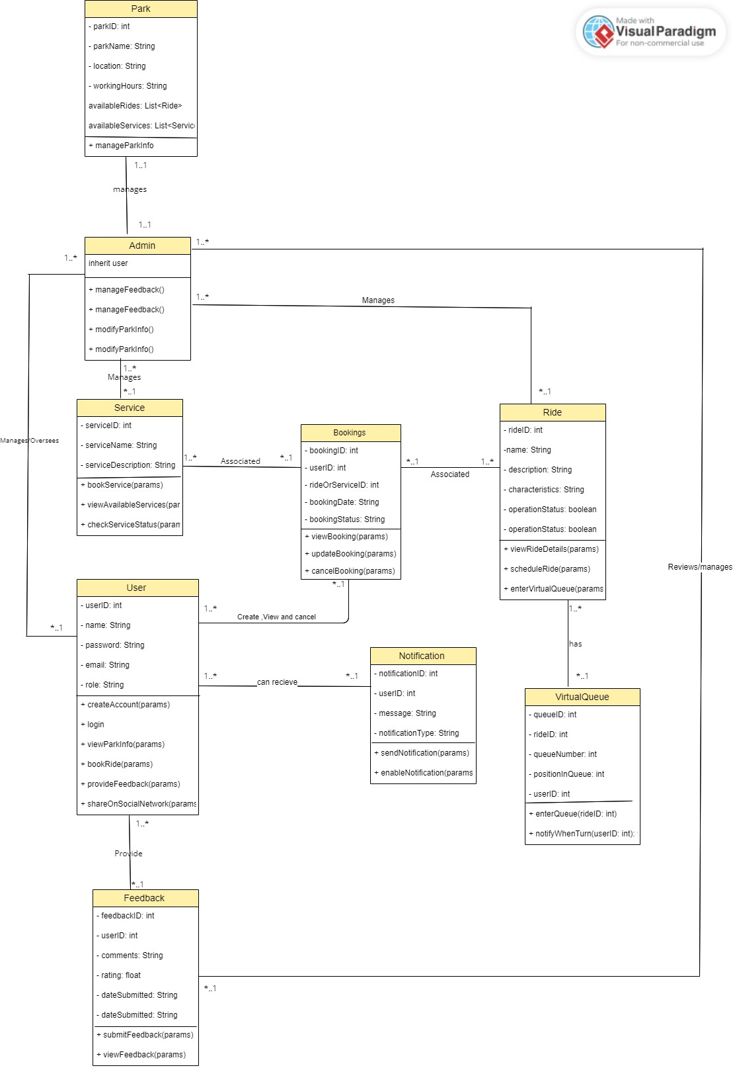

Figure 1: Class Diagram for Amusement park

Summary of the classes, relationship and notation

|  |  |  |
| --- | --- | --- |
| **Class** | **Relationship type** | **Notation** |
| User ↔ Booking | One-to-Many | User 1..* ↔ *..1 Booking |
| User ↔ Feedback | One-to-Many | User 1..* ↔ *..1 Feedback |
| User ↔ Notification | One-to-Many | User 1..* ↔ *..1 Notification |
| Admin ↔ Park | One-to-One | |  | | --- | |  |  |  | | --- | | Admin 1..1 ↔ 1..1 Park | |
| Admin ↔ Ride | One-to-Many | Admin 1..* ↔ *..1 Ride |
| Admin ↔ Service | One-to-Many | Admin 1..* ↔ *..1 Service |
| Admin ↔ Feedback | |  | | --- | |  |  |  | | --- | | One-to-Many | | Admin 1..* ↔ *..1 Feedback |
| Booking ↔ Ride/Service | Many-to-One | Booking *..1 ↔ 1..* Ride/Service |
| VirtualQueue ↔ Ride | Many-to-One | VirtualQueue *..1 ↔ 1..* Ride |
| Admin ↔ User | One-to-Many | Admin 1..* ↔ *..1 User |

**ER Diagrams**

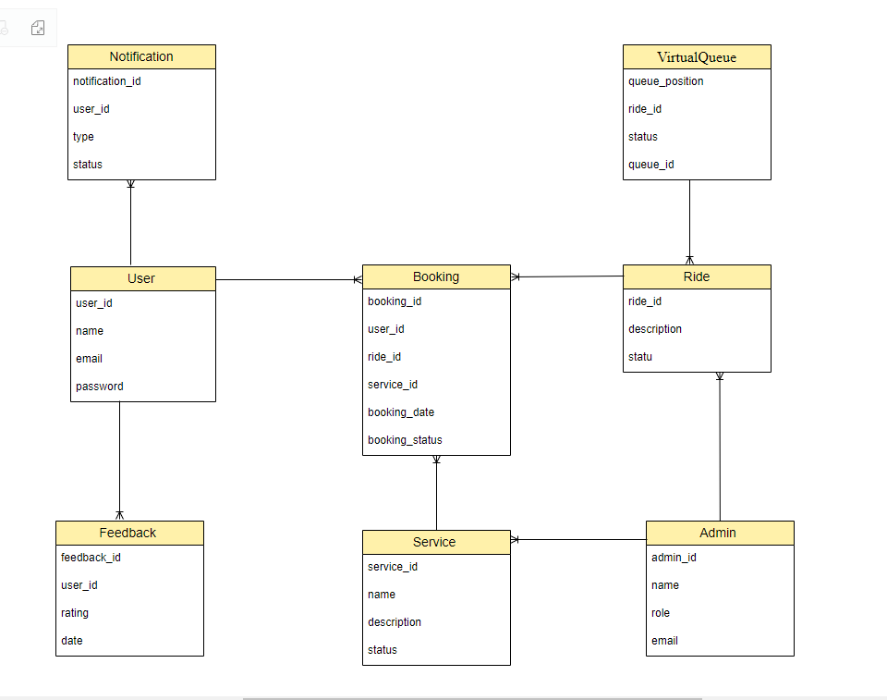

Figure 2: Shows the ER diagram

**Sequence Diagrams**

**1. User Registration**

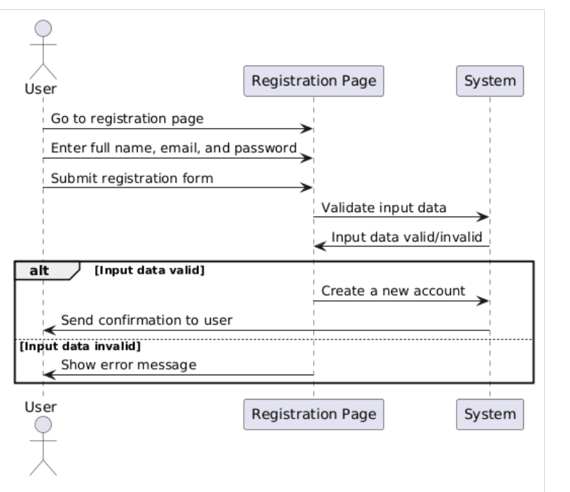

**2. User Login**

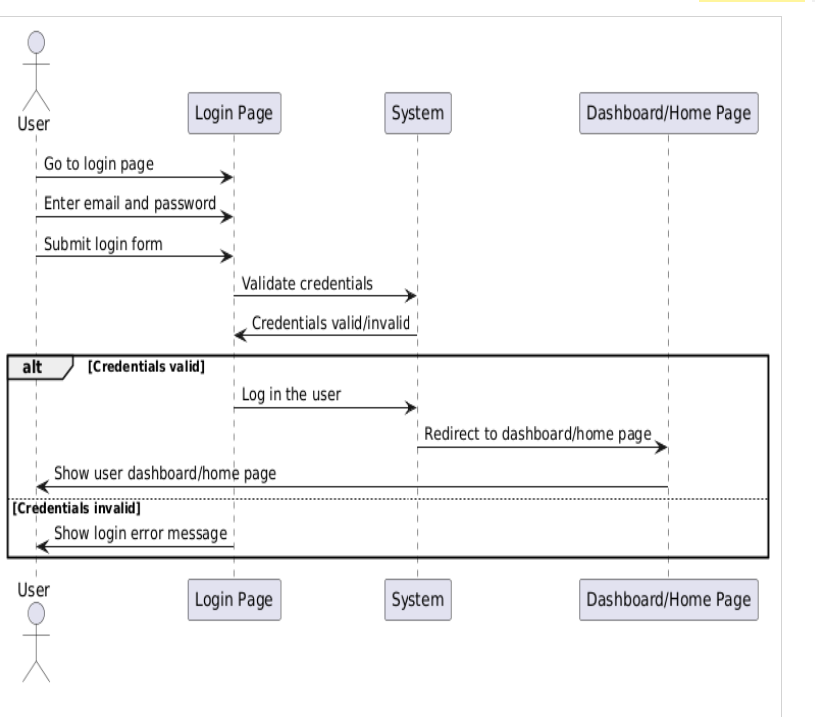

**3. View Park Information**

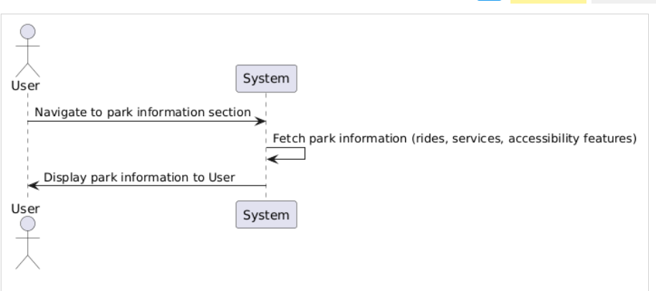

**4. Book Rides and Services**

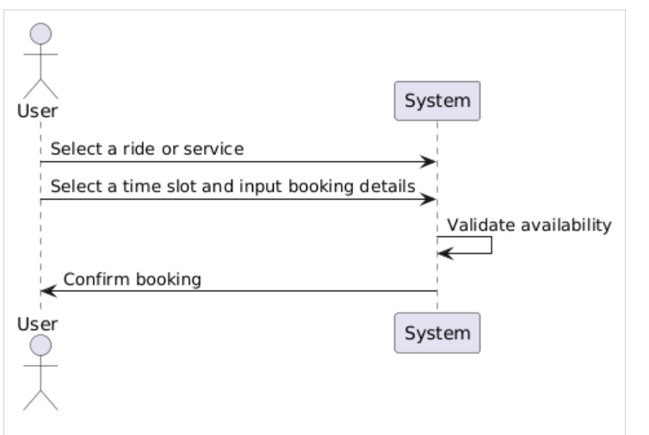

**5. Manage Bookings**

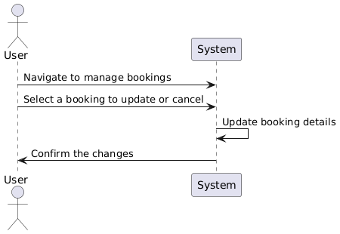

**6. Access accessibility Information**

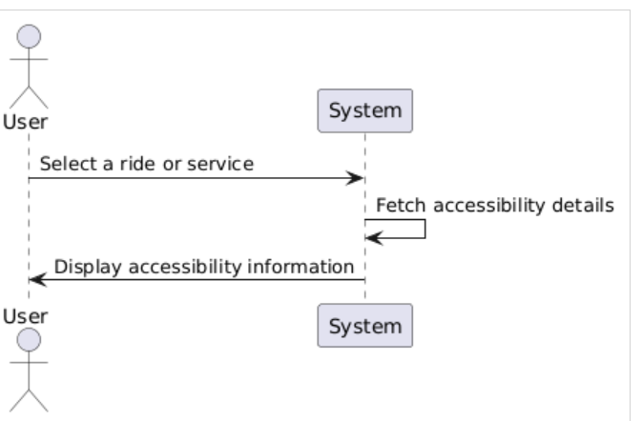

**7. Submit Feedback**

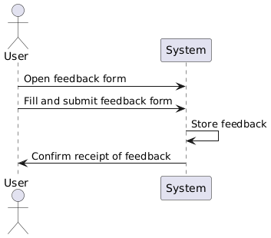

**8. Admin Login Sequence Diagram**

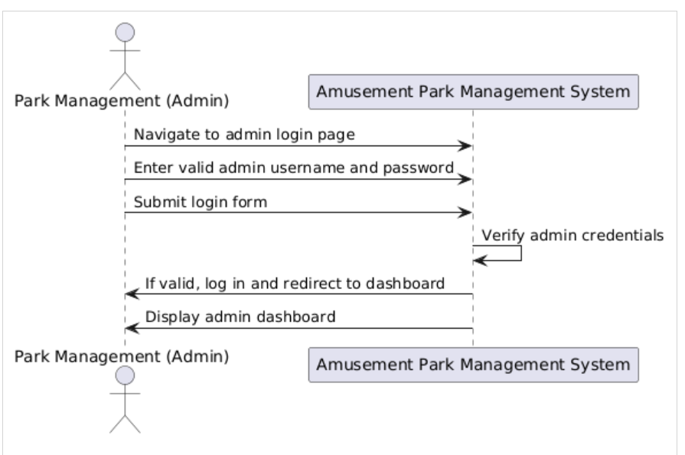

**9. Manage Park Information (Admin) Sequence Diagram**

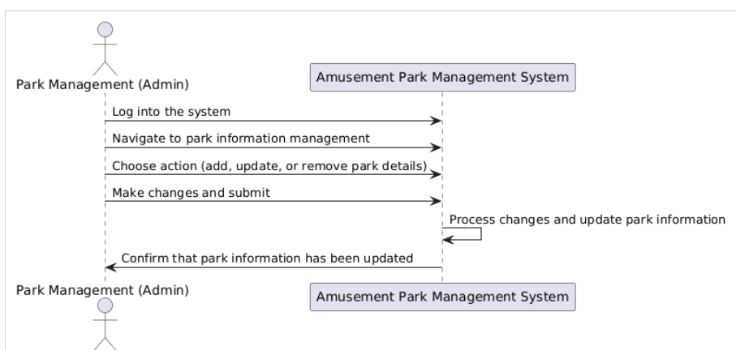

**10. Generate Reports (Admin) Sequence Diagram**

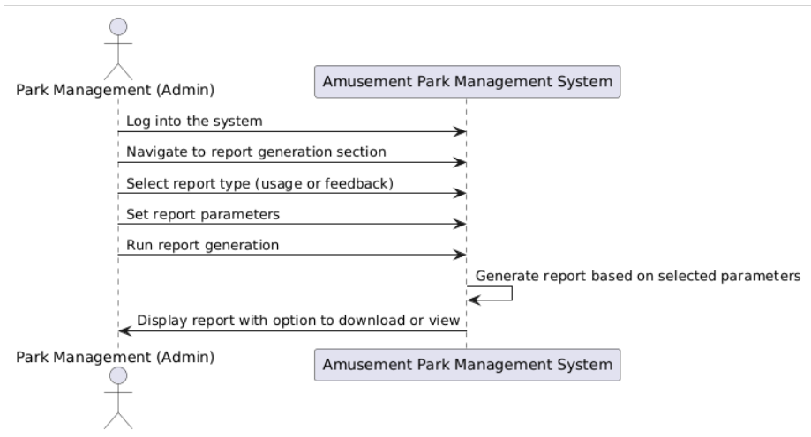

**11. Receive Real-Time Notifications Sequence Diagram**

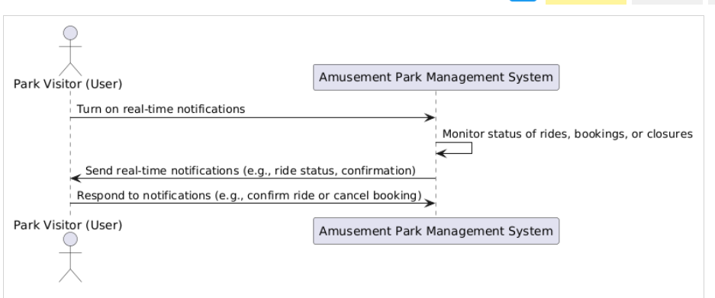

**12. Share to Social Media Sequence Diagram**

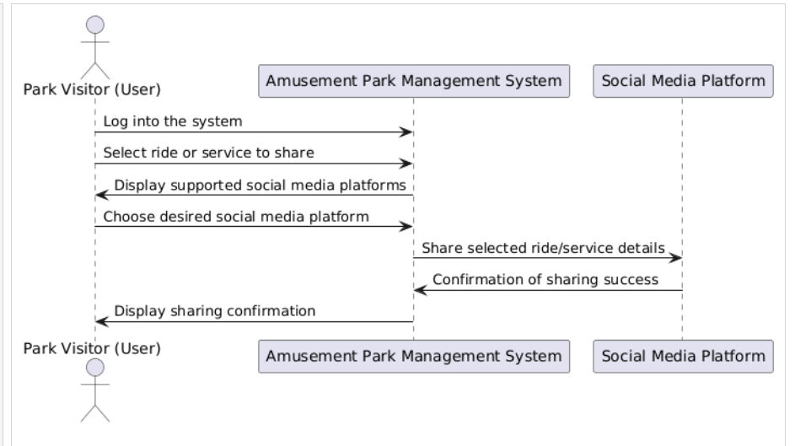

**13. Plan Personalized Itinerary Sequence Diagram**

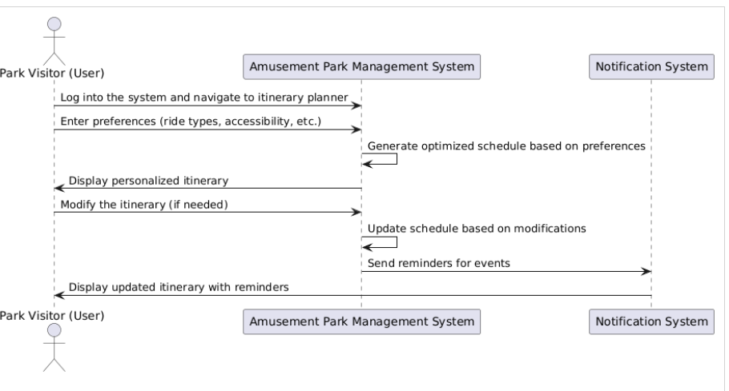

**14. Join Virtual Queue Sequence Diagram**

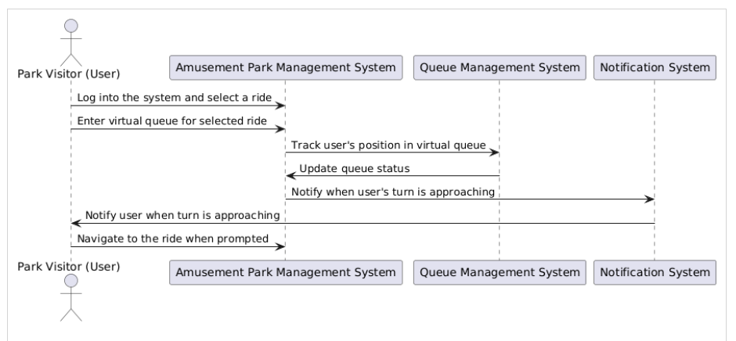

**Design Rationale**

The Amusement Park Management System aims to improve how visitors and administrators interact. This includes creating user accounts, booking rides, and viewing park information for the average user and a range of administration and analytics for park managers. This system is designed to provide an effective interaction between the users and park facilities, considering ease of access. Thus, positive satisfaction will be expected from both the park visitors and park management personnel due to the optimally structured system.

**User (Park Visitor)**

User registration page activity lets new users sign up on the platform and get an account. Customers are expected to give their first and last names, working email addresses, and passwords. The system verifies data consistency and protection and verifies account completion, which gives users access to the platform.

Users can log in with their email address and password after registration. The program guarantees the authenticity of the credentials entered, granting the user access to their individualized dashboard, which displays their bookings, preferences, and park information.

View Park Information page being physically located in the park, people visiting the place can read more about the park and the different rides, among other services. Cohorts can observe which attractions are available for guests with disabilities and sort park info based on their preferences, including the types of attractions.

In Rides and Services page, Users can book a ride and order services in this state. They get a car, decide when to pick, and type in any additional accessibility information. The system makes all the necessary checks on the booking and generates a message confirming to the user all they would require upon their visit.

Manage Bookings page allows visitors to manage their bookings. They can only view, modify, or even cancel the earlier bookings they had made. The system changes the booking status and delivers a notification to the user regarding changes, if any, allowing great flexibility to the user if plans are altered.

Park Information for readers interested in park information explains the use case where the viewer learns about the details of the rides or the services the visitors shall use. In some cases, when the visitors require information concerning access around the park, this use case allows the users to look at information regarding the particular services which are to be employed by the park users.

In Feedback submission, People can comment on their overall experience in the park, rides, and services. It provides park management with significant information that is useful in enhancing park services. User feedback is tracked, and the User receives a message indicating that their feedback input has been recorded.

Get these dimensions at the time of trip availability (UC11). Users also have the choice to be notified when the request was made and whether the product is available, booked, or cancelled. It ensures users’ applicability as they browse the park and their adaptability to the accessibility of the attractions.

Socialize with us allows Clients or visitors can share their experiences, book services or post feedback on social networks. This feature includes the ability to share the park on social media sites like Facebook; more visitors can spread the word about the park and communicate with one another after their visit. Itinerary Build Here, the User can build an itinerary based on their user choice, where/if they require extra help or services for people with disabilities or anyone requiring it or prefer the type of ride they want. Instead, rides and services always ensure they explore the facilities they wish to access.

Park Experience Feedback Users can offer their opinions on their park experience, rides, or services. Feedback is crucial for management to improve the services offered by the park. Feedback input from the User is logged, and the User gets feedback once his/her inputs have been acknowledged as received by the system.

Receive Real-Time Notifications users can opt to receive real-time updates about ride availability, booking confirmations, or cancellations. This feature ensures that users stay informed during their visit to the park and can respond quickly to any changes in ride availability.

Share to Social Media Visitors can share their experiences, ride bookings, and feedback with friends and family on various social media platforms. This feature integrates social media sharing, enhancing the park's visibility and promoting visitor interaction beyond the park's physical boundaries.

Plan Personalized Itinerary Users can create a personalized itinerary based on their preferences, including accessibility requirements and preferred ride types. The system also assists in scheduling the visitor and provides reminders of available rides or activities during the visit.

One can join virtual queues for the rides through Join Virtual Queue, reducing physical queues on the physical lines. The visitors are informed of their current position, and when it is their time to take a ride or do their activity, the park visit becomes more comfortable, and waits are shortened.

**Admin (Park Management)**

The admin login option enables the park managers to have permission to log in to the system. With this feature, administrators can go to the platform backend, where they can update information regarding parks, control user feedback, and manage parks. Manage Park Information feature allows park administrators to edit, append or delete information concerning the park. Administrators use this feature to access the platform's backend, where they can manage park information, monitor user feedback, and handle park operations.

Manage Park Information feature enables park administrators to update, add, or remove information about the park. If a new ride has been added, the ride's status has been changed, or even if the information provided is old, the admin makes sure that it is up to date with the newer changes and accurately informative to the visitors.

Managers can produce specific reports about the frequency of parks and the attitude of people towards them. They assist the park management in reviewing a specific park's performance and the customers' demands and guide them in decision-making. At the end of each report, the system may offer the user the chance to download it to generate a printable copy or to view it within the screen space in the system for immediate viewing and analysis.

By incorporating these features, the Amusement Park Management System guarantees that the park patrons and managers have adequate control and enjoyment of their park to enhance satisfaction and organizational effectiveness.

**Information Architecture Diagram**

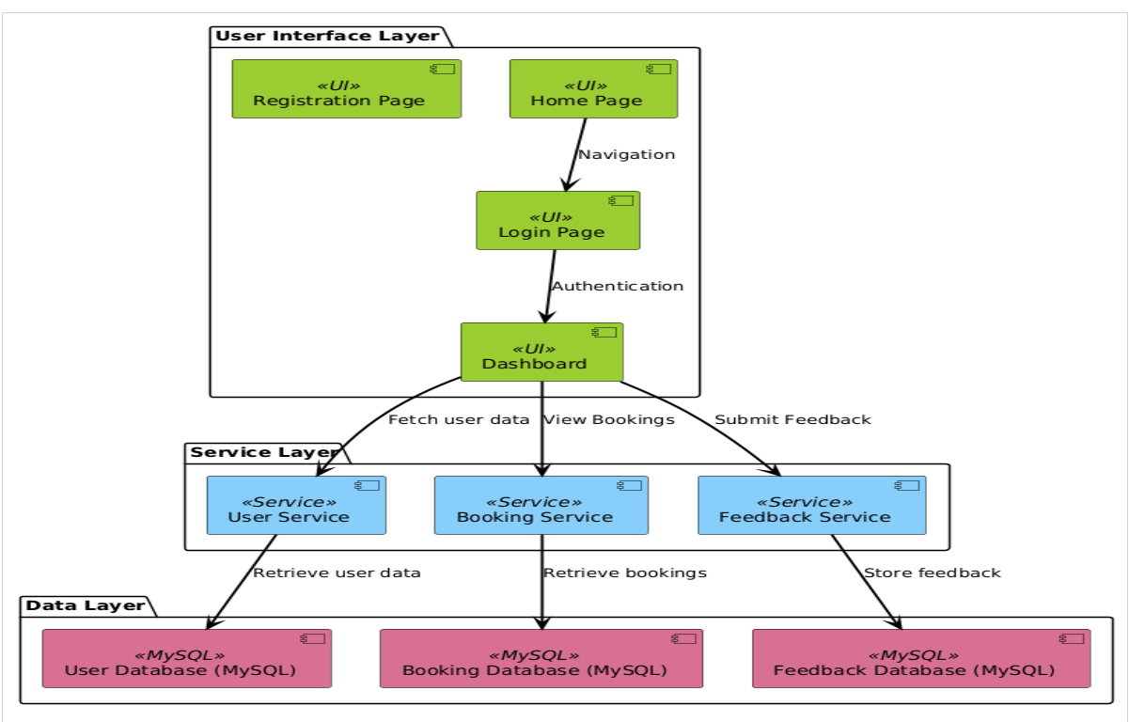

**DESIGHN DECISIONS MADE**

The decisions are to improve the system's features so that users can explore the park effectively and ease the park's working for the administrator. The User and Admin classes were created to conform to the User and Admin features and at least force the user into permission selection. To link the park-related information, new classes called Park, Ride and Service classes were incorporated so that the managers and users could share their inputs directly, which could help to share the process of managing the rides & services simplification.

Adding the class Booking, Feedback, and Notification gave clients an improved interaction opportunity where they could book in the park, return their feedback to the park, and be notified of activities in the park, respectively. To avoid more of those queues, control park movement, and increase satisfaction with the total number of visitors, a Virtual Queue class was incorporated.

However, the relations between the entities were defined based on the interaction's actual use, where the user or admin had many bookings or rides, respectively. The system's workings and the data flow have been illustrated independently in sequence and ER diagrams.

Such decisions make the system optimally organised and modular to be manageable and extendible. Park design is nested in the accessibility and functionality design concept, and this is the goal of a project deemed essential for all visitors to park.

**User Interface Wireframe(s)/Screenshot(s)**

**1. logo**

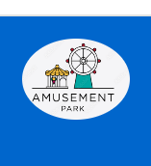

**2. Registration page**

This page will assist users in signing up for an account using their full name, a valid email address, and an appropriate password. The system improves the data quality by checking the information entered into the database. Thus, after successful registration, users will receive access to the extension to study the opportunities and services offered by the program right away.

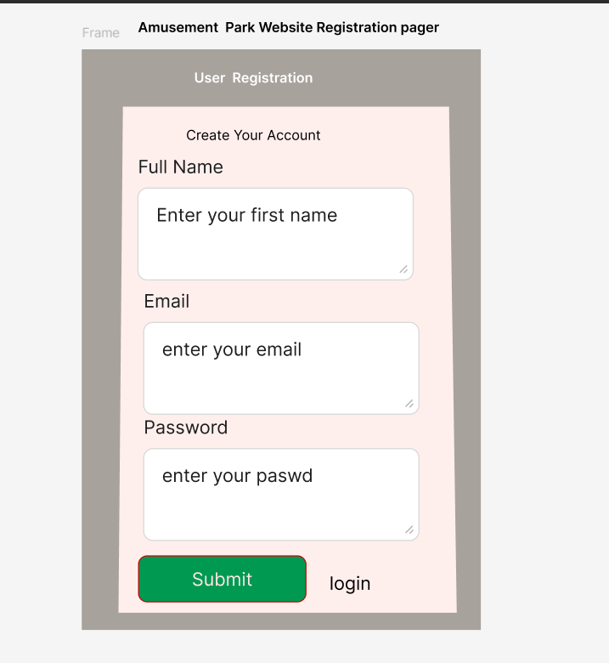

**3. Login page**

Users on this page will have to input their email addresses and passwords to access their accounts. The system then securely verifies the credentials and grants users access to their customized homepage, where they can view bookings, input preferences and other park-related information.

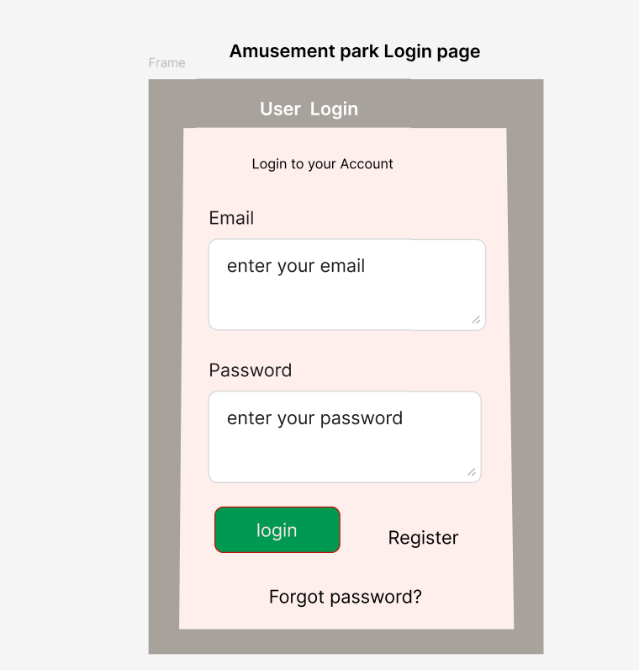

**4. Home page**

This page provides an introduction to the Accessible Amusement Park and explains that this park is designed for all guests, including those who have a disability. The page inspires people to go into the park and have fun with words, noticeably pushing for easy access. It also provides links to the “Home”, “About”, “Register”, and “Login” pages where users can get the information they need or create an account on the platform.

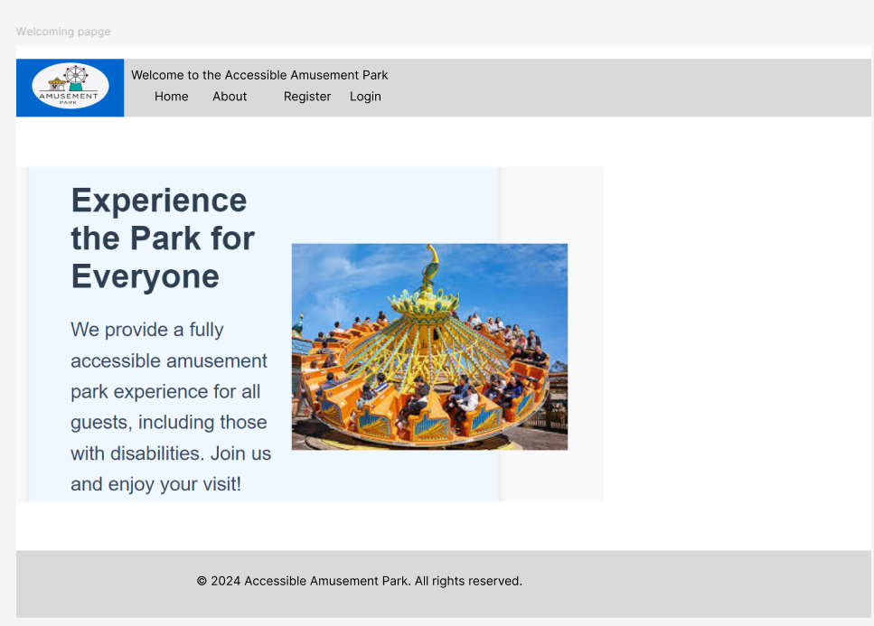

**4. User (Park Visitor) Dashboard**

This page is for the user to control the Accessible Amusement Park. After logging in, customers can view park information, book rides and services, modify and cancel bookings, review accessibility information, provide feedback, receive real-time updates, and create a customized itinerary. People may even join other virtual queues and promote a visit on social media as people meet them when visiting. To prevent unauthorized access, the page contains an option to log out.

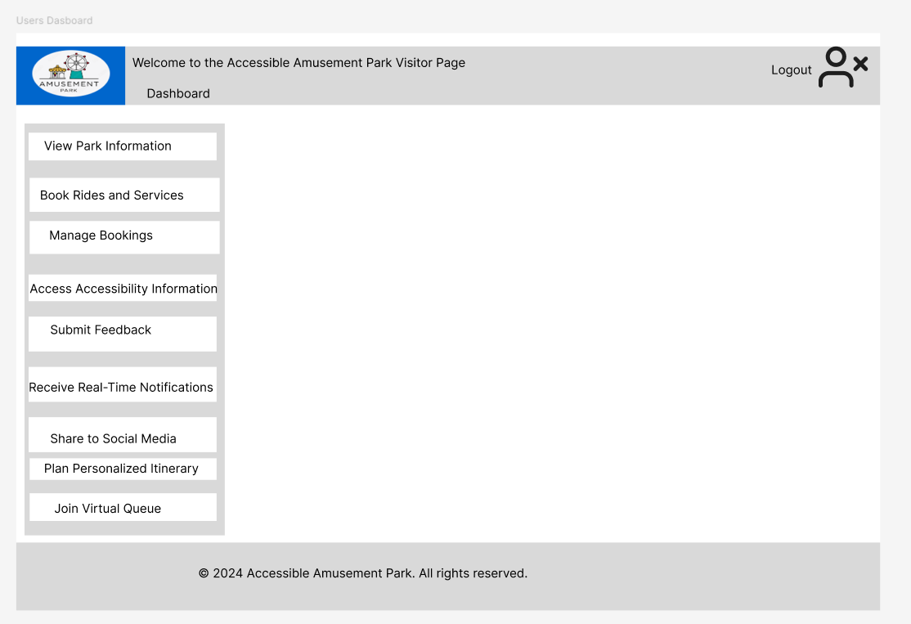

**5. View park information**

This page enables the user to look for park information; this page displays enjoyable rides present and services offered. Visitors can sort through options to find the places they want to experience. For example, potential passengers could see more information about the rollercoaster ride, which was characterized as an exciting experience suitable for fans of risky entertainment, and so on. Every ride also consists of a ‘More Info’ button to give users more information about the park and what it offers them.

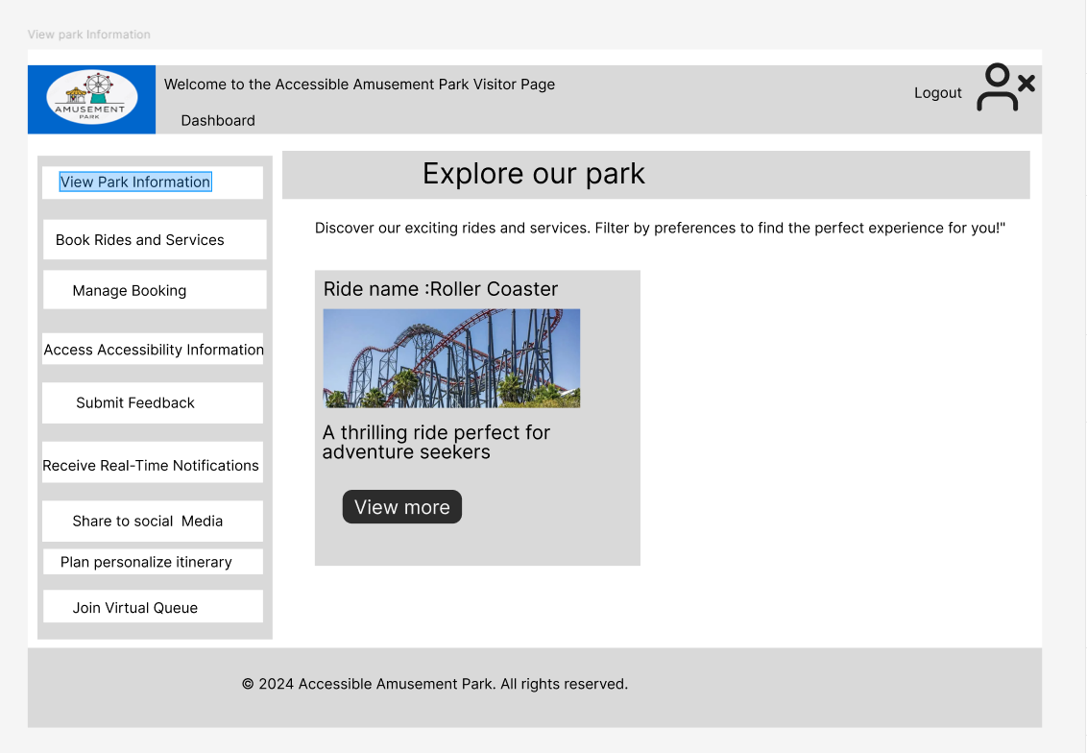

**6. Book rides**

This page allows visitors to arrange transport at the Accessible Amusement Park. They include choices of full name, email, and ride, including a Roller Coaster. It offers buttons where users can access park information differently, reserve or purchase park services, fill in feedback, etc. A “Book” button confirms the rider’s reservation for the booked ride service.

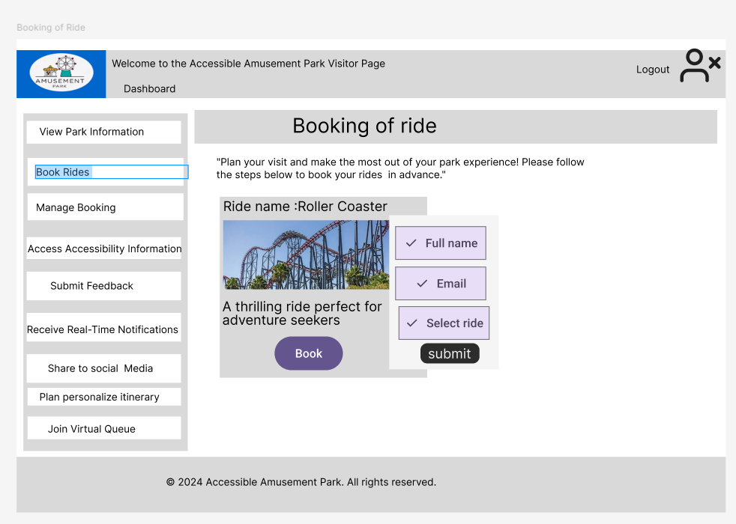

**7. Manage Booking**

This “Manage Booking” page lets users cancel or change their ride at the Accessible Amusement Park. The page shows user details such as name, the email used, and the chosen ride. Buttons to either “Edit” or “Save” are allowed for users with the intention of either modifying their ride bookings or confirming them. Extra features of the park are also provided in the side menu.

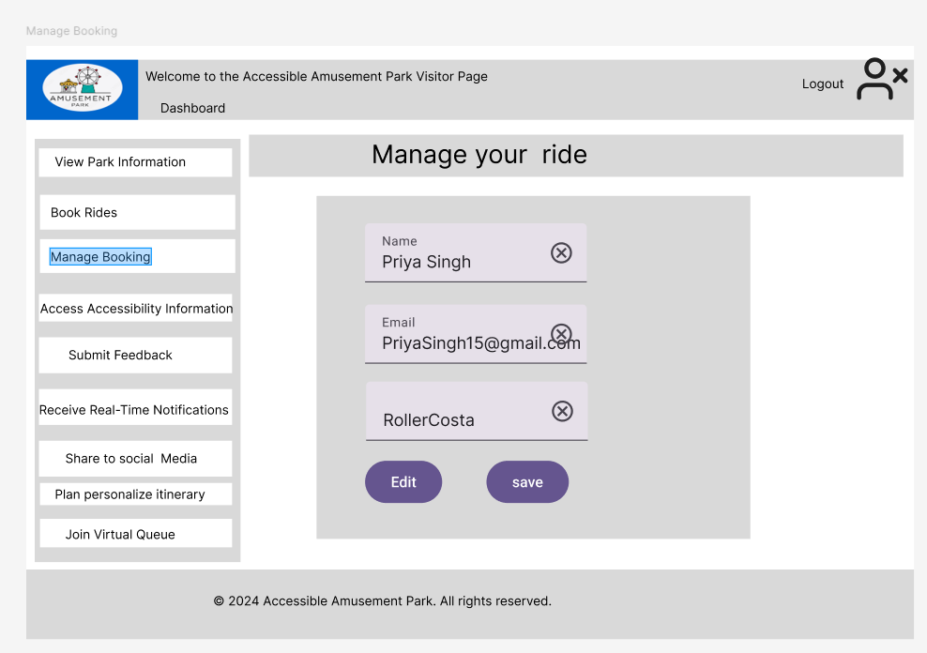

**Admin (Park Management)**

The Admin Dashboard page contains features that assist park administrators in running the park. It comprises features to update information on parks, produce reports, and take a look at the users’ responses. The central panel greets the admin and tells them to control park details, comments, and reports to increase performance.

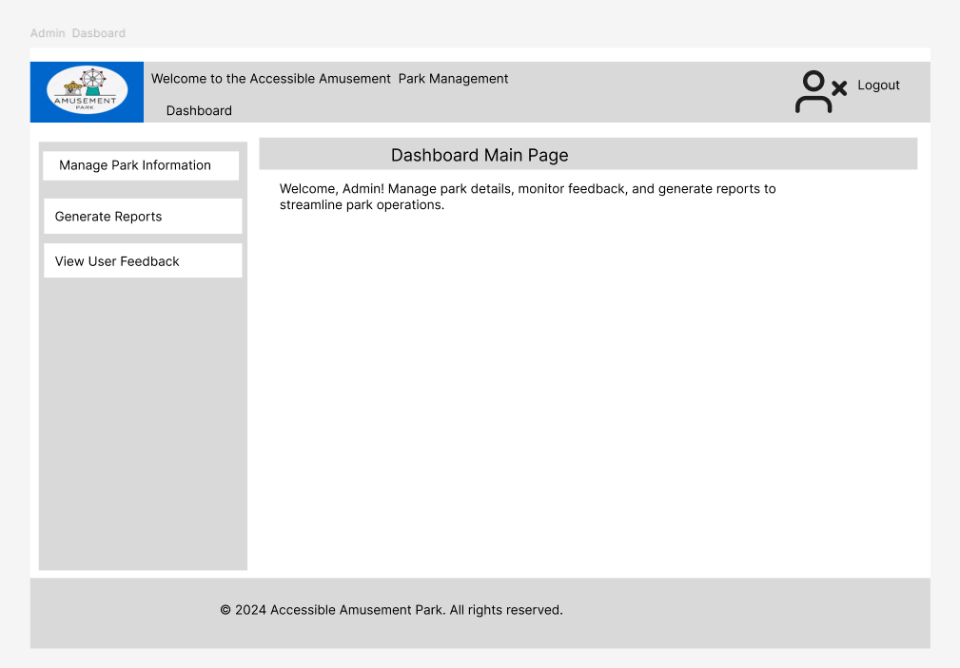

This “Manage Booking” page lets users cancel or change their ride at the Accessible Amusement Park. The page shows user details such as name, the email used, and the chosen ride. Buttons to either “Edit” or “Save” are allowed for users with the intention of either modifying their ride bookings or confirming them. Extra features of the park are also provided in the side menu.